**Programs on Strings and Varargs**

1. **Write a program to calculate the area of rectangle, square, and circle. Use Method Overloading Write a program to perform the following functions on an array: (Use string input for an array)**
2. **Checks the length of an array using length ().**

**Logic:**

Step 1: Start

Step 2: package welcome;

Step 3: public class ar{

Step 4: So now in a new java class declare an array of numbers.

Step 5: Now we have to use .length() keyword find the length of the array and print the result

Step 6: Stop

**Code:**

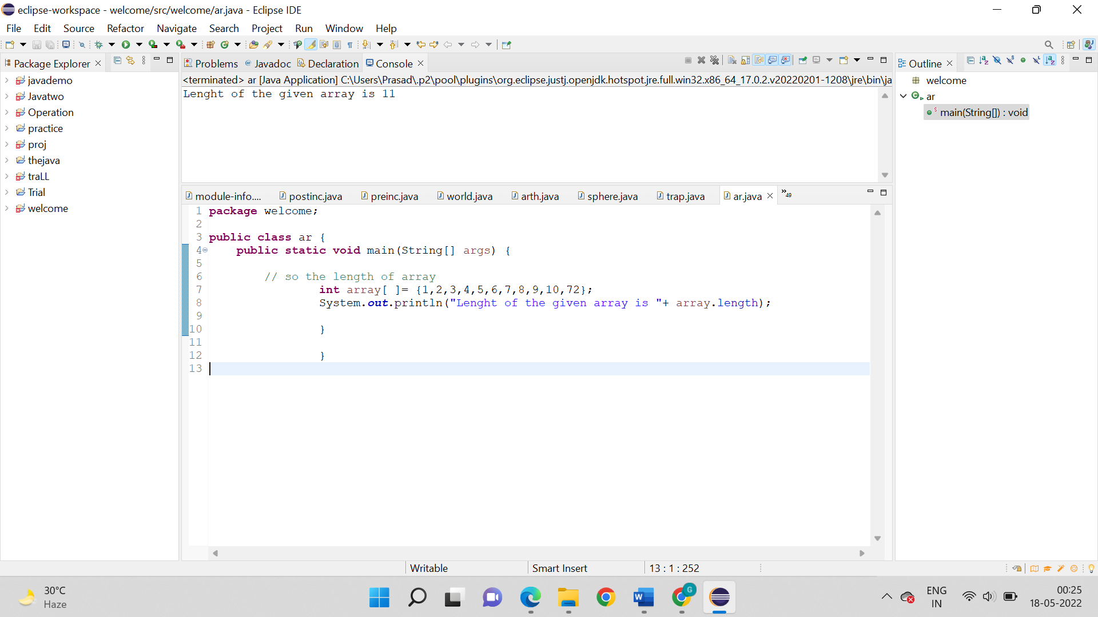

**Output:**



1. **Checks whether the two arrays are equal using equals ().**

**Logic:**

Step 1: Start

Step 2: package welcome;

Step 3: public class giveaccess1{

Step 4: So, now in a new java class declare three string variables

Step 5: After step 4 we have to then in an if…else operator, use equals operator to check if two variables are same are not

Step 6: Print results accordingly.

Step 7: Stop

**Code:**

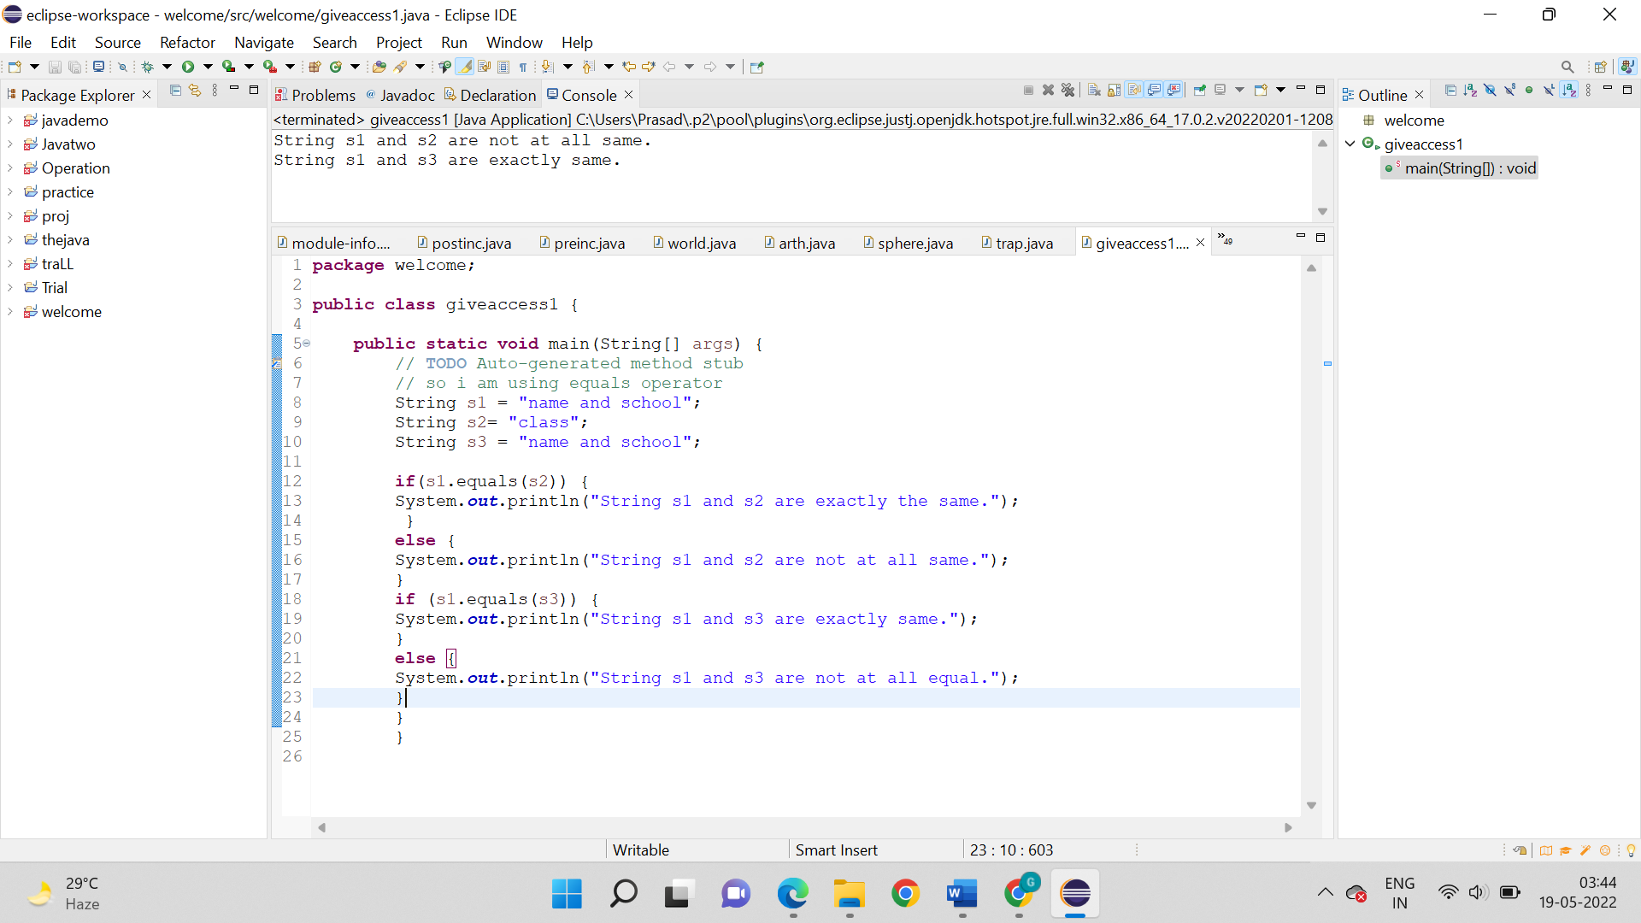

**Output:**



1. **Determines the character at a preferred index using charAt (). Characters should be more than 15.**

**Logic:**

Step 1: Start

Step 2: package welcome;

Step 3: public class ar_1{

Step 4: So, we have to make a new java class declare a string.

Step 5: Now, we have to use charAt() keyword find the letter at that specific position.

Step 6: Stop

**Code:**

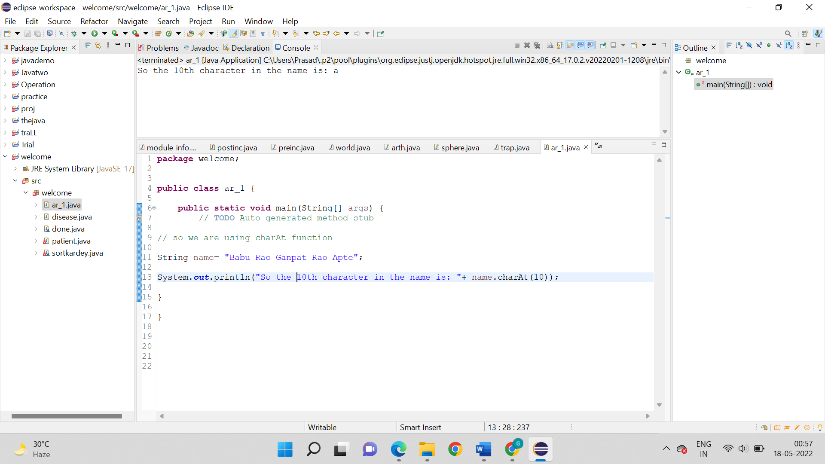

**Output:**



1. **Write a program to print the contents of an array passed through the command line.**

**Logic:**

Step 1: Start

Step 2: class ca{

Step 3: We have to open notepad and start writing java code.

Step 4: As shown we have to declare a class and main method.

Step 5: Then use a for loop, set the conditions and also the result we want to print.

Step 6: So, now we have to save the file anywhere in the computer. I have saved in the Documents.

Step 7: Now you have to open command prompt and set the path where the file is saved.

Step 8: We have to use “javac filename.java” first the java file will be converted to class file.

Step 9: After the step 8 us “java filename (input)” command to finally run the code.

Step 10: Now the results will be printed automatically

Step 11: Stop

**Code:**

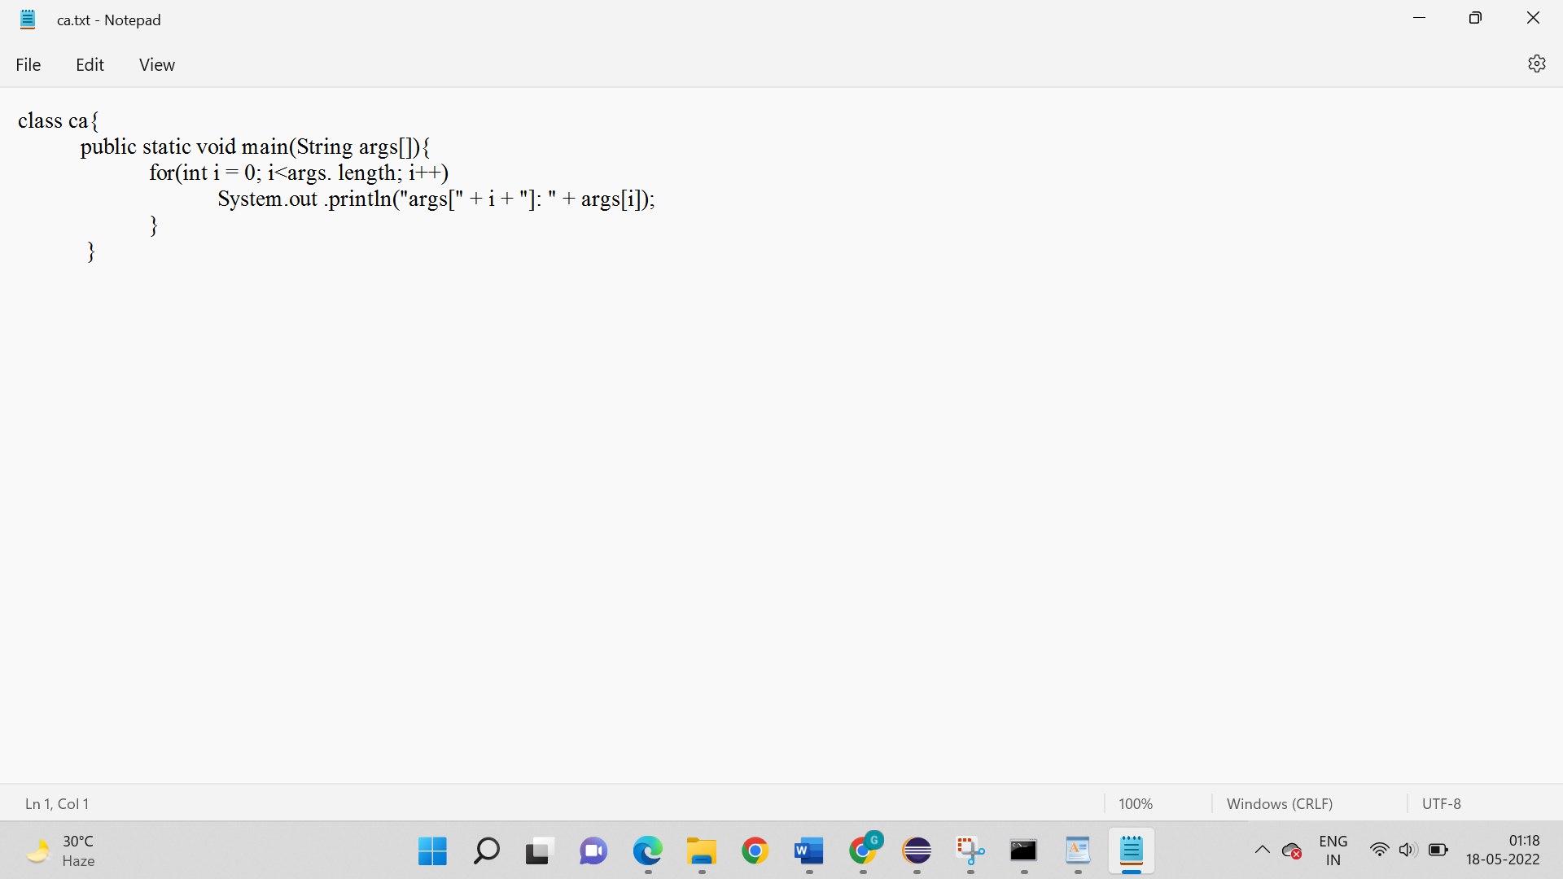

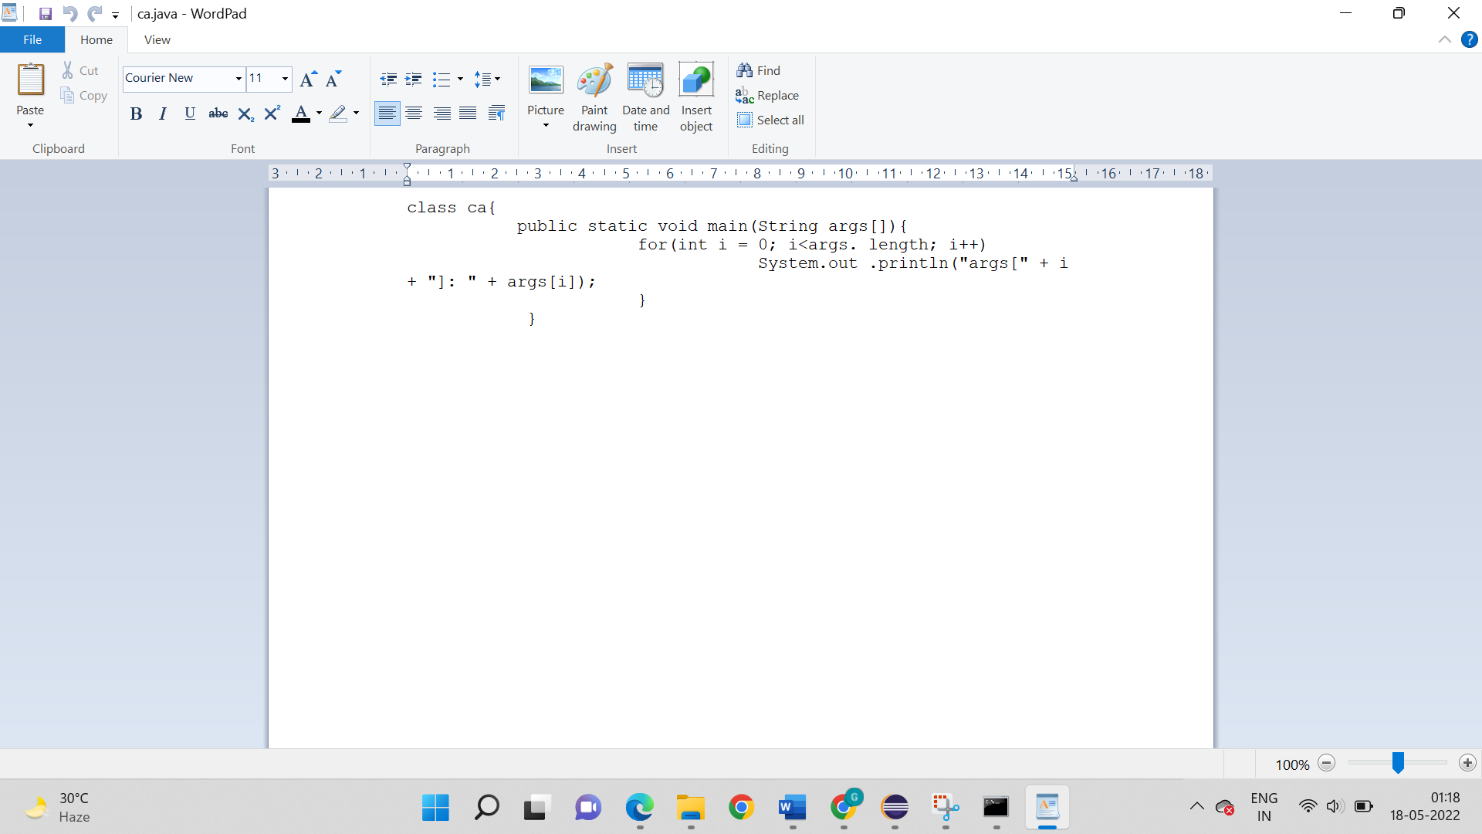

**Class file is generated:**

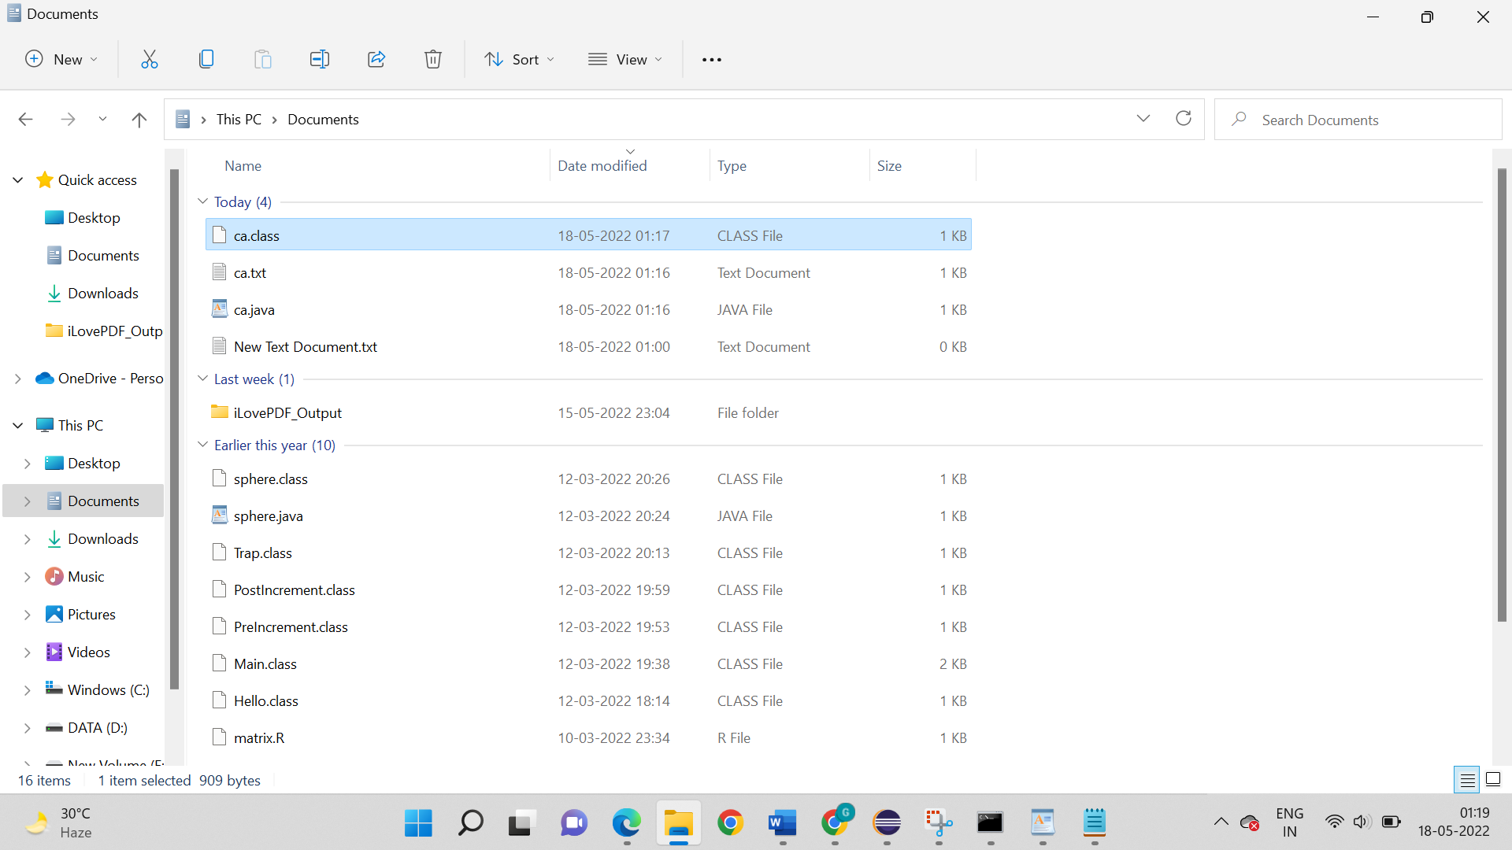

**Output:**

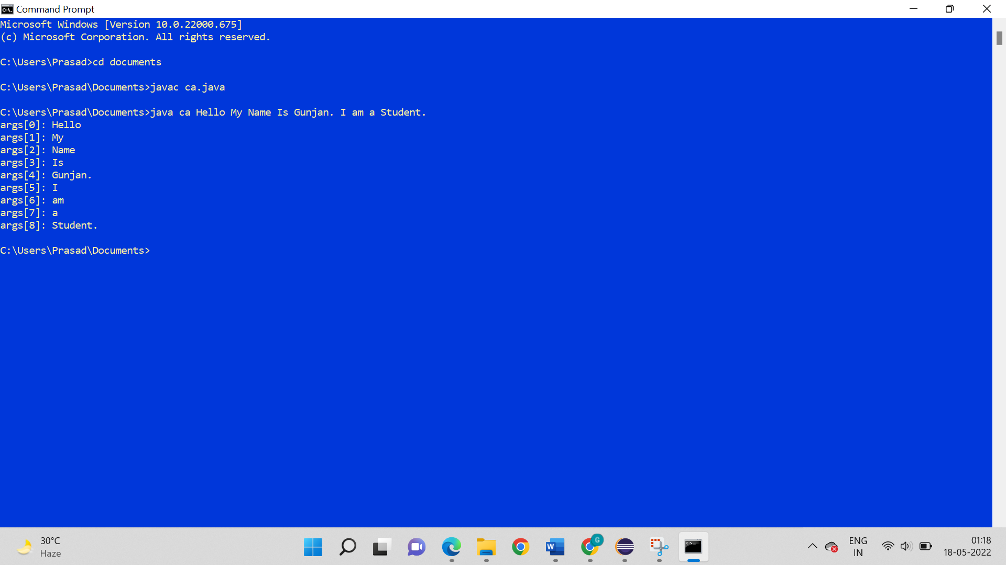

1. **Write a program to define the following methods and display those using varargs ( ): Use int … for both the sub-questions.**
2. **Takes Strings and an integer**

**Logic:**

Step 1: Start

Step 2: package welcome;

Step 3: public class ar_1{

Step 4: Now we have to declare a java sub-class and declare a method that will receive a string and variable number of integers.

Step 5: So, after step 4 use for loop print the result.

Step 6: We have to pass in the main method we will pass all the values to the defined class

Step 7: Stop

**Code:**

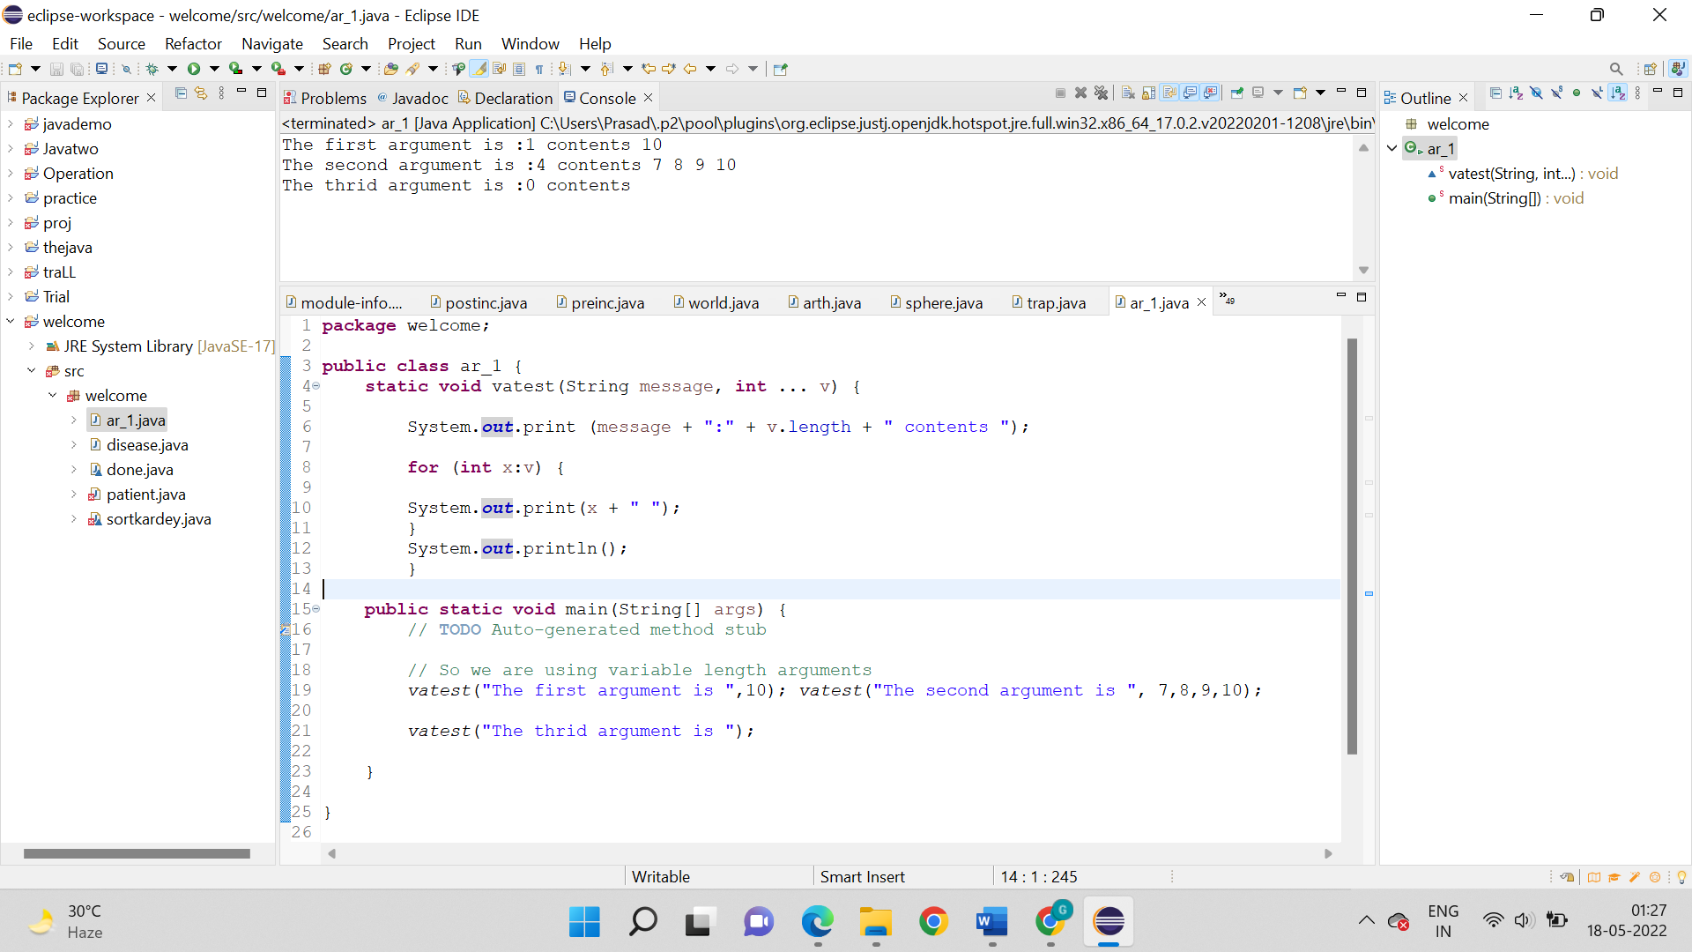

**Output:**



1. **Takes double and an integer**

**Logic:**

Step 1: Start

Step 2: package welcome;

Step 3: public class ar_1{

Step 4: We have to first declare a java sub-class and declare a method that will receive a decimal/double value and variable number of integers.

Step 5: So, now we have to us for loop print the result.

Step 6: After that in the main method we will pass all the values to the defined class.

Step 7: Stop

**Code:**

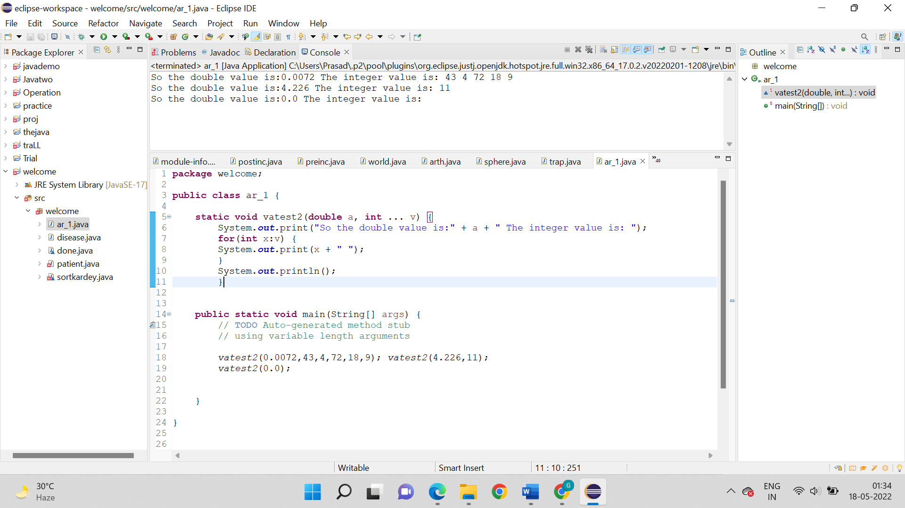

**Output:**

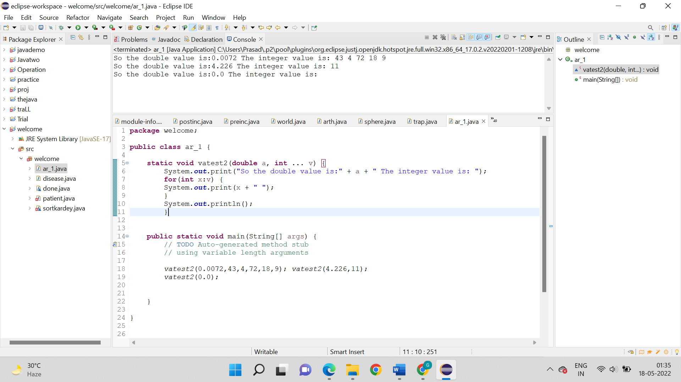

1. **Write a program to add two numbers. Demonstrate the concept of overloading of varargs ( ). Use two methods one that takes an integer and other takes double type of value.**

**Logic:**

Step 1: Start

Step 2: package welcome;

Step 3: public class ar_1{

Step 4: So, we have to declare a class and declare two methods.

Step 5: Now after the step 4 we have to take one method and will receive variable number of integers and other will receive variable number of double values. Also in both the methods there will be for loop to print the statements.

Step 6: We have to now declare the main method and pass the values to the respective method.

Step 7: Stop

**Code:**

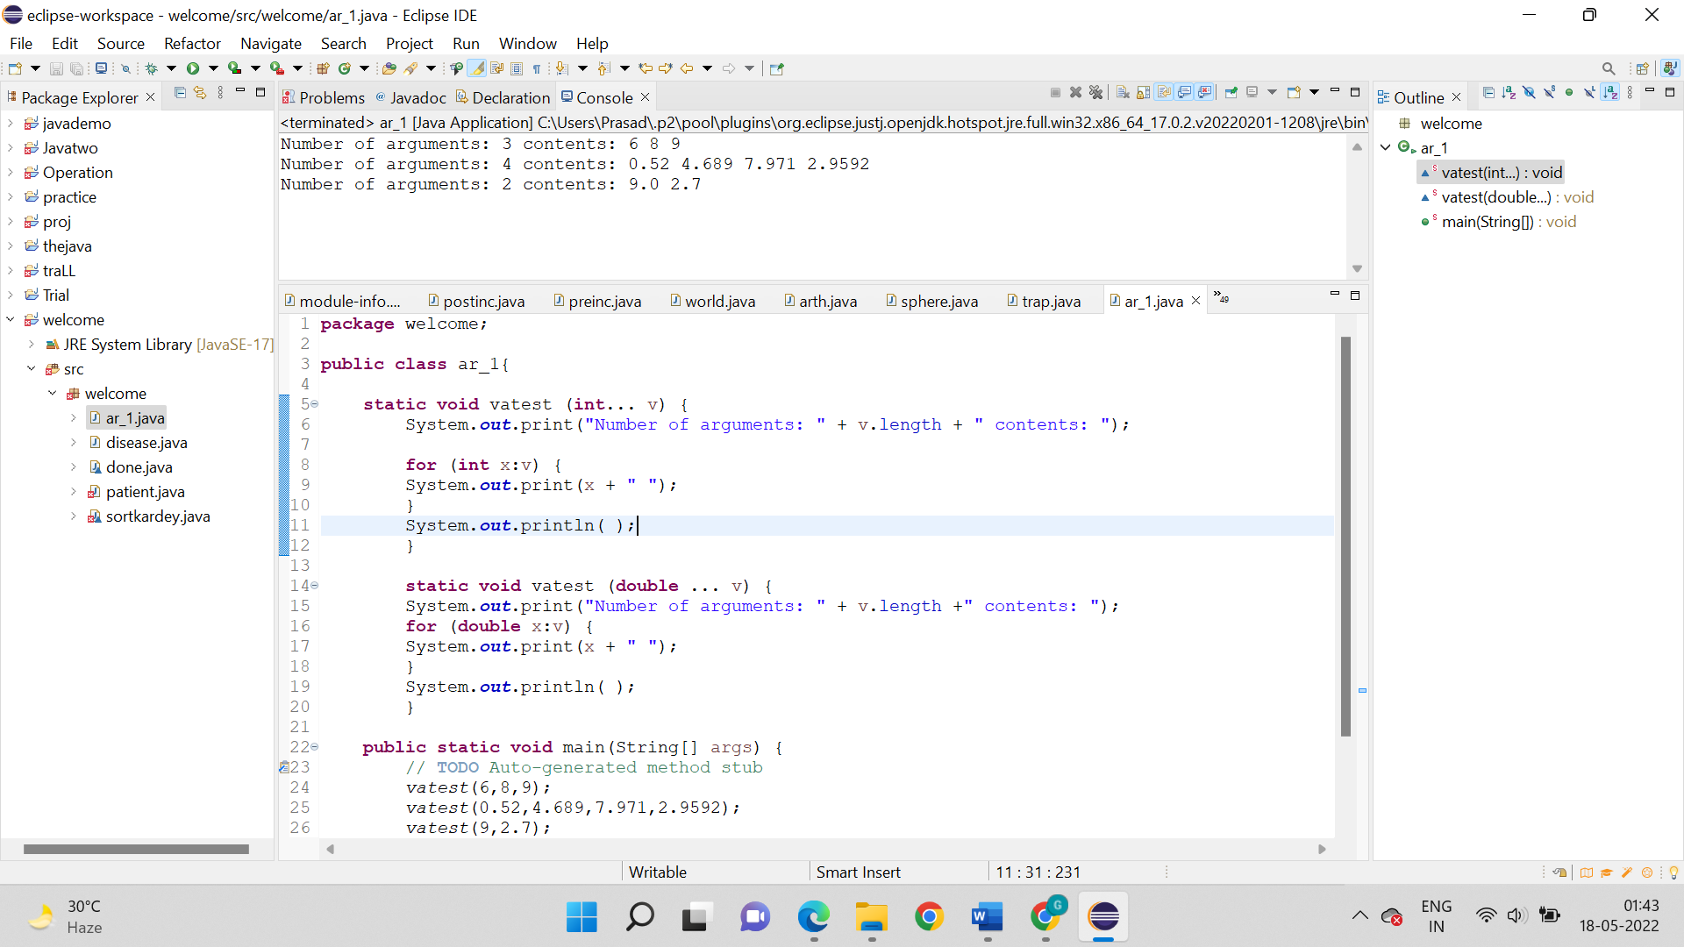

**Output:**

